Call-for-Papers: The International Cross Domain Conference for Machine Learning & Knowledge Extraction CD-MAKE is a joint effort of IFIP TC 5, IFIP WG 8.4, IFIP WG 8.9 and IFIP WG 12.9 and is held in conjunction with the International Conference on Availability, Reliability and Security (ARES) and takes place in Reggio (Italy) from August, 29 to September, 1, 2017.
CD stands for Cross-Domain and means the integration and appraisal of different fields and application domains (e.g. Health, Industry 4.0, etc.) to provide an atmosphere to foster different perspectives and opinions. The conference is dedicated to offer an international platform for novel ideas and a fresh look on the methodologies to put crazy ideas into Business for the benefit of the human.
MAKE stands for MAchine Learning & Knowledge Extraction.
Papers are sought from the following seven topical areas. Papers which deal with fundamental questions and theoretical aspects in machine learning are very welcome.
❶ Data science (data fusion, preprocessing, data mapping, knowledge representation),
❷ Machine learning (both automatic ML and interactive ML with the human-in-the-loop),
❸ Graphs/network science (i.e. graph-based data mining),
❹ Topological data analysis (i.e. topological data mining),
❺ Time/entropy (i.e. entropy-based data mining),
❻ Data visualization (i.e. visual analytics), and last but not least
❼ Privacy, data protection, safety and security (i.e. privacy aware machine learning).
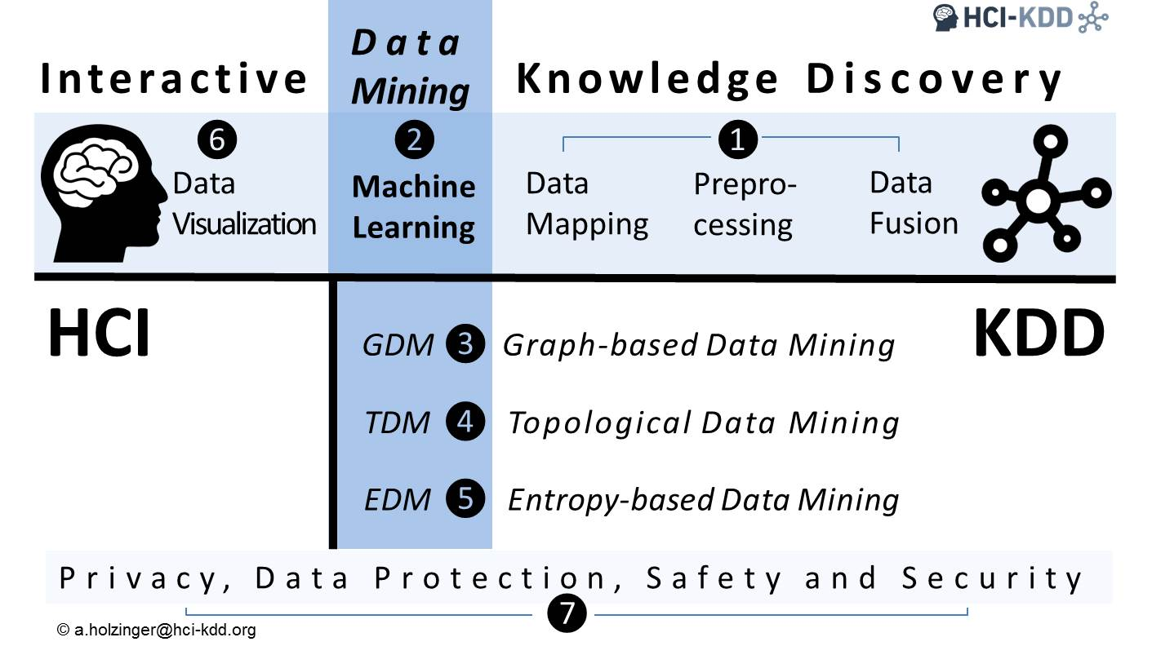
Proposals for Sessions/Workshops/Tutorials: April, 19, 2017
Paper Submission Deadline: May, 15, 2017
Accepted Papers will be published in a Springer Volume of Lecture Notes in Artificial Intelligence (LNAI), and outstanding contributions will be invited to special issues of journals.
For more information please visit the conference homepage:
https://cd-make.net

